School of Digital Competences
INDIVIDUAL DATA ANALYSIS PROJECT
Yelizaveta Sivitskaya
21.1.2026

PROJECT HIGHLIGHTS

Objective and Data Selection: The dataset was compiled from the open-source ChEMBL database and contains information on MAO-B (monoamine oxidase B) inhibitors. It includes approximately 8,000 entries combining chemical structures (SMILES), biological activity values (pChEMBL), and key physicochemical descriptors.
Relevance: MAO-B is an important therapeutic target in the treatment of neurodegenerative and psychiatric disorders, including Parkinson’s disease and depression. Analysis of the chemical space of MAO-B inhibitors is essential for identifying new compounds with high activity and favorable pharmacokinetic properties.
Software stack: Data preprocessing and machine learning were performed using Python libraries (Pandas, Scikit-learn, RDKit, NumPy), while statistical analysis and visualization were carried out in R (ANOVA, ggplot2, networkD3). This combination enables efficient handling of large datasets and robust statistical interpretation.

PROJECT MILESTONES

- Descriptive and visual statistics: structural analysis of 5,884 compounds, calculation of baseline indices (Mean, Median), and construction of histograms and boxplots to assess the distribution of physicochemical properties and pChEMBL.

- Data visualization: A comprehensive exploratory data analysis (EDA) and data audit were performed. Distributions were examined using histograms, box plots, and violin plots. Implementation of an interactive Sankey diagram in HTML format for analyzing hierarchical relationships between molecules and scientific publications.

- Statistical Hypothesis Testing: Evaluation of activity differences across compound groups using t-tests, ANOVA, and Chi-square tests in R to ensure data-driven conclusions.

- Multivariate analysis: segmentation of chemical space using principal component analysis (PCA) and K-Means algorithm on the reduced PCA coordinates to segment the compounds into distinct groups based on structural and property similarities. The resulting clusters were visualized through color-coded scatter plots, providing insights into the distribution and diversity of the analyzed inhibitors.

- Predictive Modeling: Development of a Random Forest classification model to predict activity levels. The model was used for forecasting the potential of new or hypothetical drug candidates.

CONTENT

PROJECT HIGHLIGHTS 1
PROJECT MILESTONES 1
DATA PREPARATION 3
Dataset Overview and Feature Structure 3
Target Cleaning and Duplicate Removal 3
Time Variable Transformation 4
Feature Selection and Column Reduction 5
Data Type Validation 6
Feature Analysis 6
VISUAL DATA ANALYSIS 8
Summary 17
HYPOTHESIS EVALUATION 18
Difference in Activity by Source Type 18
The Impact of Ro5 Violations on Activity 18
Correlation of Molecular Weight and pChEMBL 19
Proportion of active molecules by Source Type 20
Document Year Effect 20
Time_hr 21
PREDICTIVE MODELING 23
Forecasting New Data 25
MULTIDIMENSIONAL ANALYSIS 27
Clustering – Segmentation 29
RESULT REPORT 30

DATA PREPARATION

Dataset Overview and Feature Structure
The initial phase of the study involved a comprehensive audit of the MAO-B inhibitors dataset. The structure was examined by analyzing the dimensions of the data matrix, comprising approximately 8,000 entries and a diverse set of physicochemical and biological features. To ensure data integrity, a diagnostic inspection of the first several observations and column metadata was performed.
We performed a rigorous review of data types to categorize features into numerical (e.g., pChEMBL, Molecular Weight) and categorical (e.g., Source Type, Document Year) variables. This differentiation was crucial for the strategic selection of subsequent statistical tests and allowed for the correct application of visualization techniques tailored to each data type.
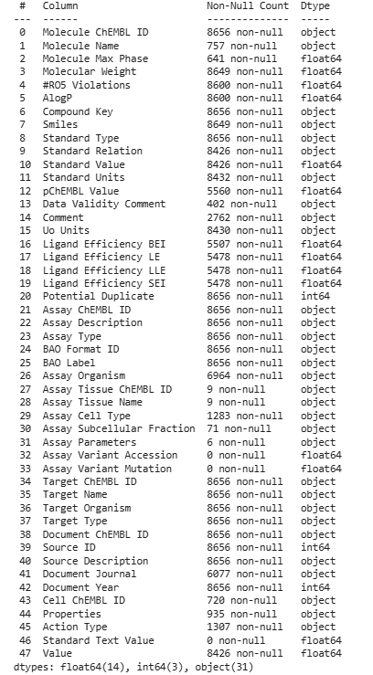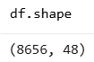
Figure 1: Dataset overview

Target Cleaning and Duplicate Removal
The target variable was cleaned to ensure consistency and correctness for further analysis. Invalid and non-informative entries were removed prior to modeling. To prevent statistical bias and avoid the over-optimization of models on repeated data, a global duplicate identification protocol was executed. Identical SMILES strings associated with repeated measurements were either averaged or removed, ensuring that each observation in the final dataset represents a unique chemical entity. This step was essential for maintaining a balanced and representative chemical space.
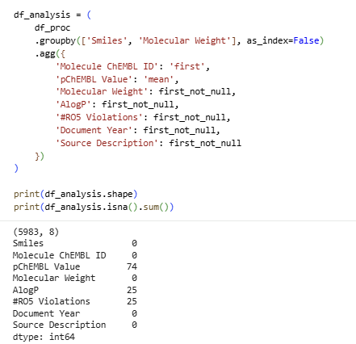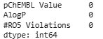
Figure 2: Cleaning
Completeness of the dataset was addressed by identifying and managing null values. For critical numerical features, missing values were carefully evaluated; observations with missing target values (pChEMBL) were excluded to maintain the high reliability of the supervised learning phase.

Time Variable Transformation

A key part of the preprocessing involved transforming raw data into a machine-readable format. The time-related variables, originally stored as descriptive text (e.g., "1 hr", "24 hr"), underwent a numerical transformation. By stripping string suffixes and converting the values into a continuous numeric scale (Time_hr), we enabled the use of these variables in quantitative correlation analyses and time-series trend evaluations.
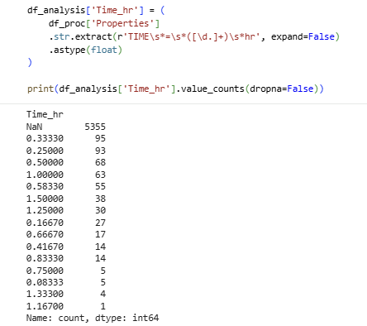
Figure 3: Time variable

Feature Selection and Column Reduction
To optimize computational efficiency and improve the interpretability of the results, a strategic feature selection process was conducted. Redundant or irrelevant columns—such as internal database IDs, raw SMILES (after descriptor extraction), and sparse metadata—were removed. By focusing exclusively on features with high variance and clear biological or chemical relevance, we reduced the risk of "the curse of dimensionality" and enhanced the model's ability to generalize to new data.
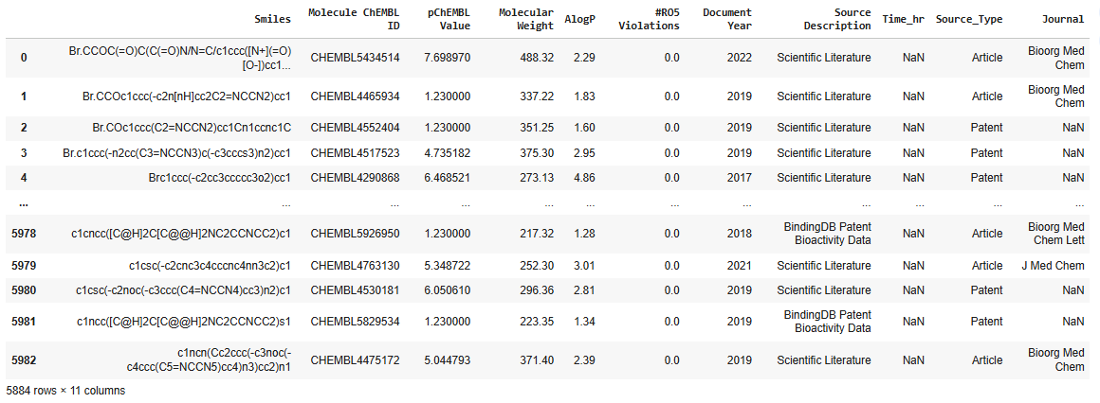
Figure 4: Feature Selection

Data Type Validation
The final phase of the cleaning pipeline focused on the rigorous validation of data formats to ensure seamless integration with downstream analytical tools. All feature data types were verified and, where necessary, cast into appropriate formats (e.g., converting integer-coded categories into factors or ensuring floating-point precision for pChEMBL values).
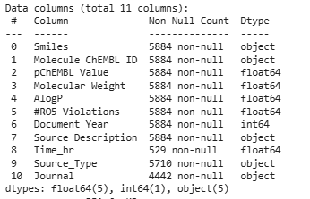

Figure 5: Validation

This step was critical to satisfy the strict input requirements of both R-based statistical functions and Scikit-learn’s machine learning estimators. By ensuring that numerical features were recognized as continuous and class labels as categorical, we eliminated the risk of logical errors during the execution of ANOVA tests and Random Forest training. These preprocessing refinements significantly enhanced the overall data quality, establishing a reliable foundation for robust and reproducible statistical inferences.

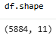
Figure 6: Final dataset

Feature Analysis
Once the dataset was cleaned and validated, a multi-layered feature analysis was conducted to map the chemical landscape of the inhibitors. We performed a deep inspection of the dataset's internal structure, cross-referencing column data types with the presence of any remaining sparse values.

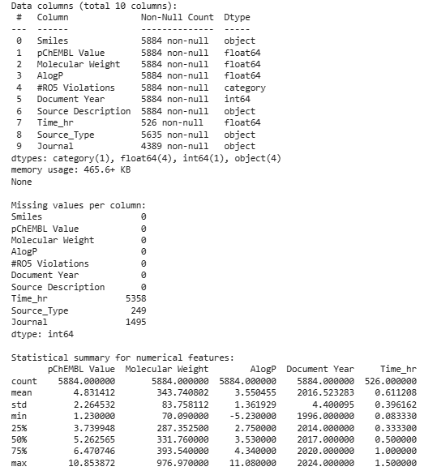
Figure 7: Feature descriptive statistics
To gain a quantitative understanding of the data, we calculated a suite of basic descriptive statistics for all numerical features, including mean, median, standard deviation, and interquartile ranges (IQR). This profiling allowed us to summarize the distributions and identify the value ranges of key descriptors like AlogP and Molecular Weight. These insights were instrumental in detecting skewness and potential outliers, providing the necessary context for interpreting the results of the subsequent multidimensional and cluster analyses.

VISUAL DATA ANALYSIS

The visual exploration phase employed a robust suite of analytical tools, including box plots and histograms, to rigorously evaluate data distributions and identify potential outliers within the chemical space. To further unravel the complex interplay between molecular descriptors, correlation heatmaps were implemented, providing a high-resolution map of the interdependencies and statistical relationships between key numerical features.
- HISTOGRAM:
To evaluate the underlying structure of the data, histograms were generated using varying bin sizes to ensure a granular understanding of the feature density.
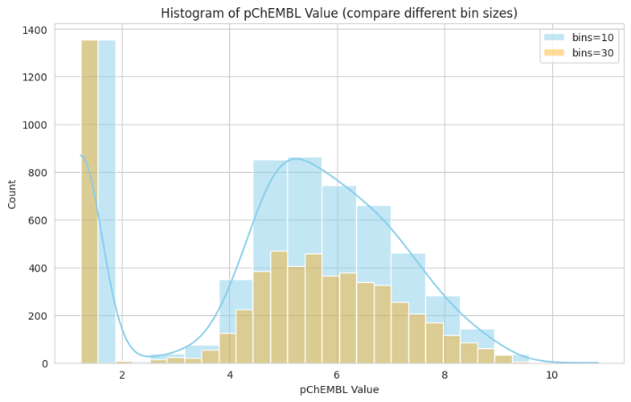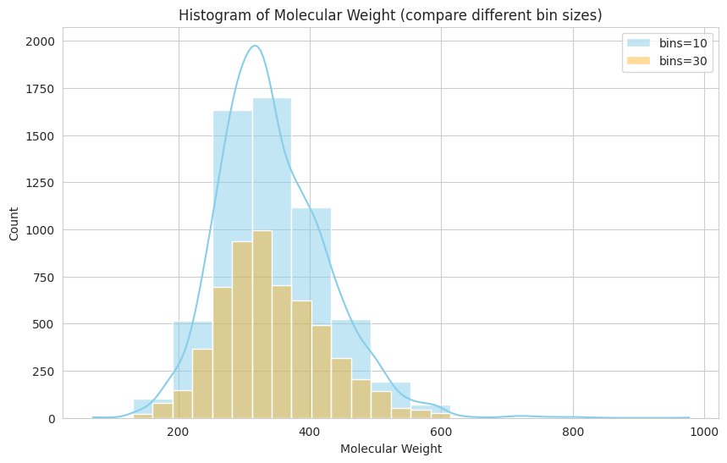
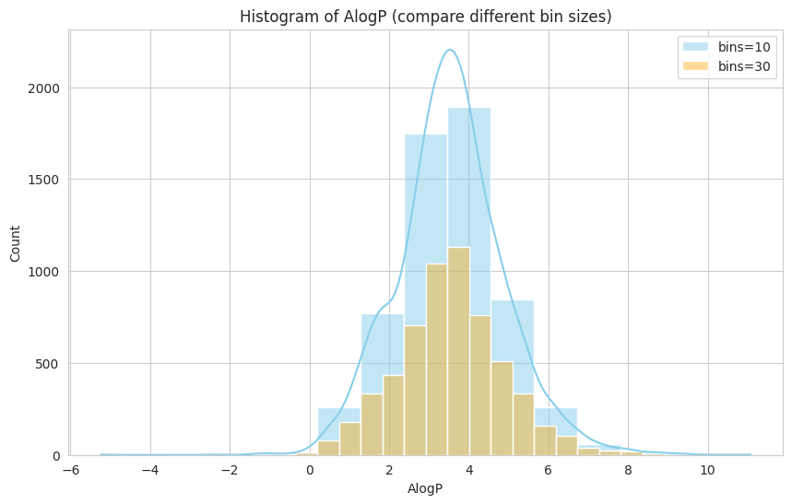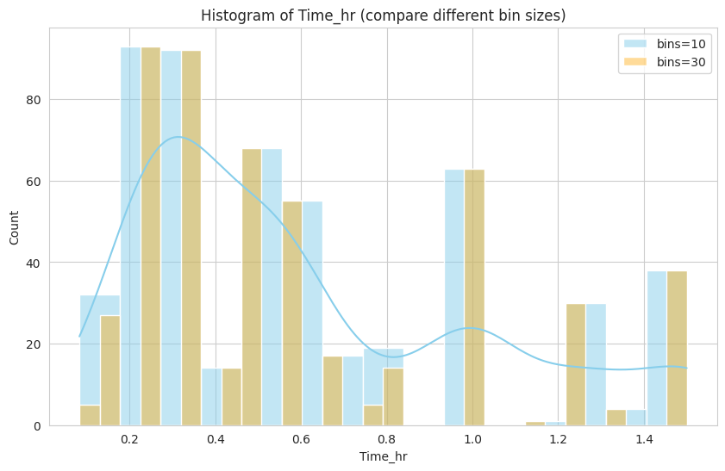
Figure 8: Histograms
- pChEMBL Activity: The activity distribution is bimodal, showing a high frequency of compounds with low activity (values around 1.0–2.0) and a second, broader distribution representing moderately active compounds peaking between 5.0 and 6.0.
- Molecular Weight: The majority of the compounds are concentrated within a drug-like range of 250–400 Da. The density curve indicates a relatively normal distribution in this core range, though it exhibits a long tail extending toward larger molecular structures.
- AlogP (Lipophilicity): The lipophilicity profile shows a strong concentration between 2.0 and 5.0, which is typical for compounds targeting the central nervous system.
- Experimental Time (Time_hr): The distribution of incubation times is discrete rather than continuous, with clear peaks at specific intervals (e.g., 0.2, 0.5, 1.0, and 1.5 hours), reflecting standardized experimental protocols used in the source studies.

- BOX PLOTS + OUTLIERS:
The distribution of key numerical features was evaluated using box plots to identify central tendencies and statistical anomalies.
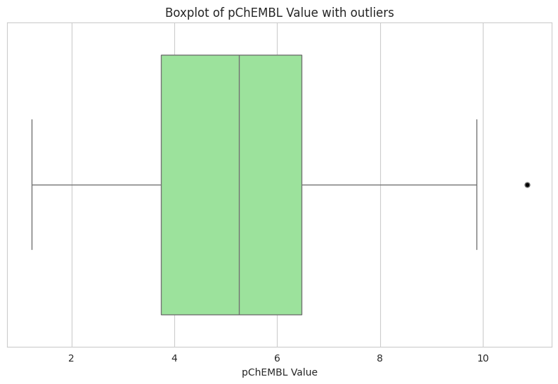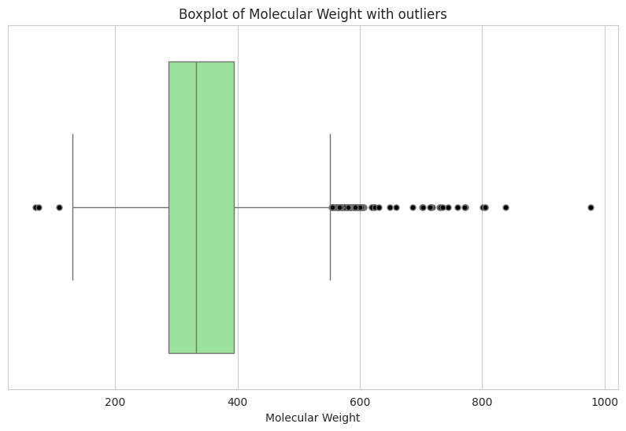
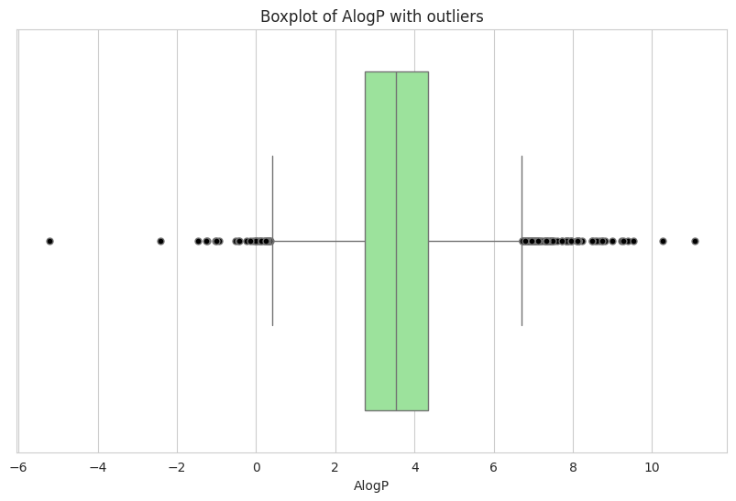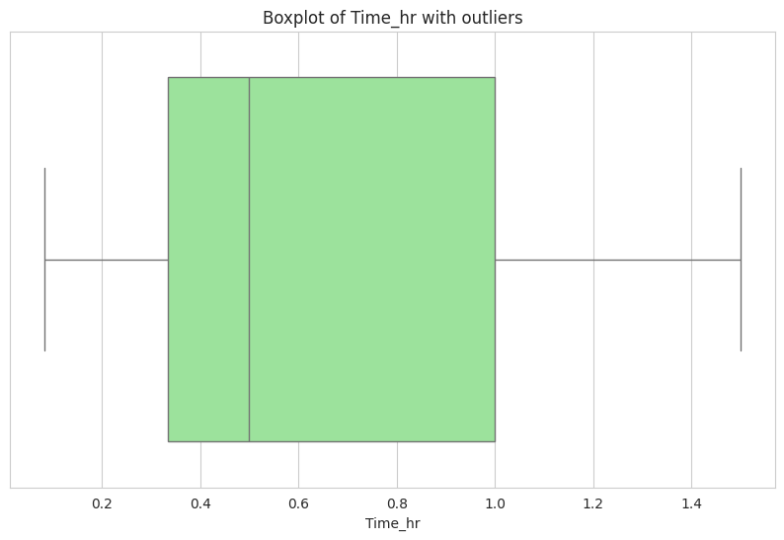
Figure 9: Box Plots
- Activity Variance: The pChEMBL values range from approximately 1.0 to over 10.0, with the median value situated near 5.0. A notable high-activity outlier was identified at a pChEMBL value of approximately 11.
- Structural Anomalies: Significant outliers were detected in the Molecular Weight category, with several compounds reaching nearly 1000 Da, well beyond the typical range of the main dataset.
- Physicochemical Extremes: AlogP visualizations revealed extreme outliers on both ends of the spectrum, with values dropping below -4 and exceeding 10, indicating a diverse range of solubility profiles in the analyzed chemical space.
- Time Metrics: The experimental duration (Time_hr) has a median of 0.5 hours, with the bulk of the data contained within a 1.0-hour window.

- SCATTER PLOTS: Molecular Weight vs AlogP by RO5 Violations
A scatter plot was employed to analyze the interplay between Molecular Weight and AlogP, while simultaneously mapping compliance with the #RO5 (Rule of Five) Violations.
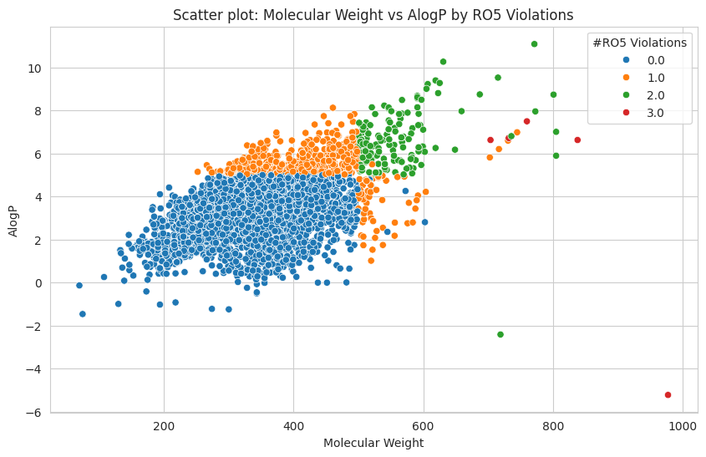
Figure 10: Scatter Plot
A preliminary analysis of the descriptor distribution revealed that the library consists predominantly of compounds with molecular weights in the 300–400 Da range and moderate lipophilicity (AlogP ≈ 3,5), consistent with classical concepts of "drug-like" chemical space. The pChEMBL Value histograms demonstrate a bimodal profile: a significant portion of compounds exhibit low potency, but a distinct group of highly potent molecules is present.
- VIOLIN PLOTS: Violin plot: pChEMBL Value by Source Type
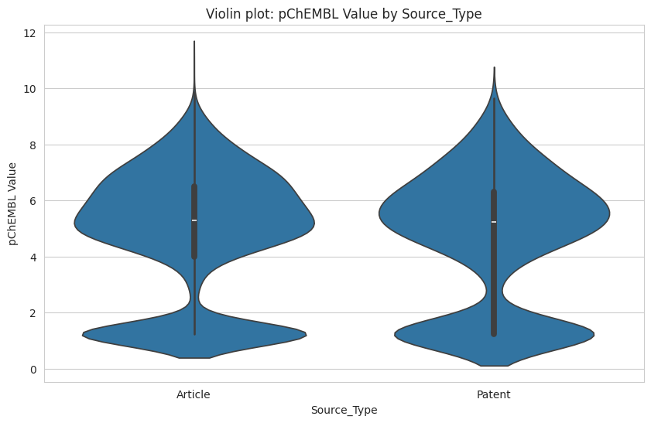
Figure 11: Violin Plot
The violin plots illustrate the probability density of pChEMBL values (a measure of biological activity) across two primary data sources: Articles and Patents. Both sources exhibit a similar bimodal distribution, with a significant concentration of activity values around a pChEMBL of 5–6 and a secondary peak at lower activity levels (near 1). This suggests that while both sources provide high-potency data, the overall distribution of reported molecular activity is remarkably consistent regardless of whether the data originates from academic literature or patent filings.

- QUANTITY / COUNT GRAPHS: Count of molecules by Year, Journal
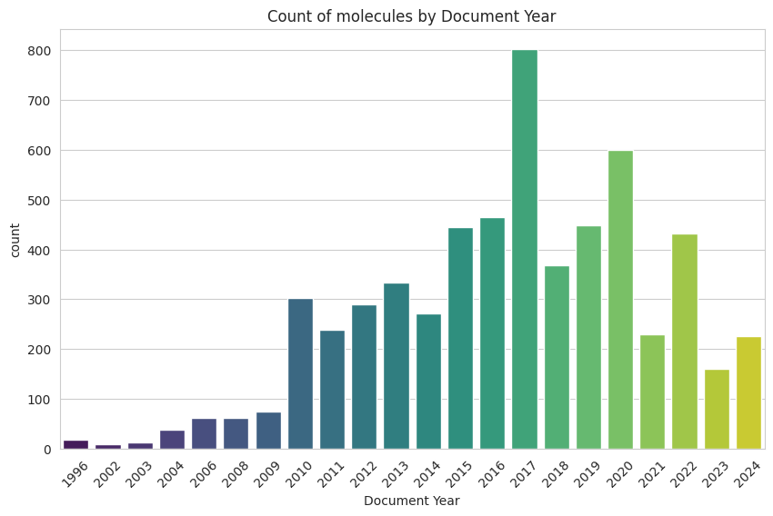
Figure 12: Quantity Graph
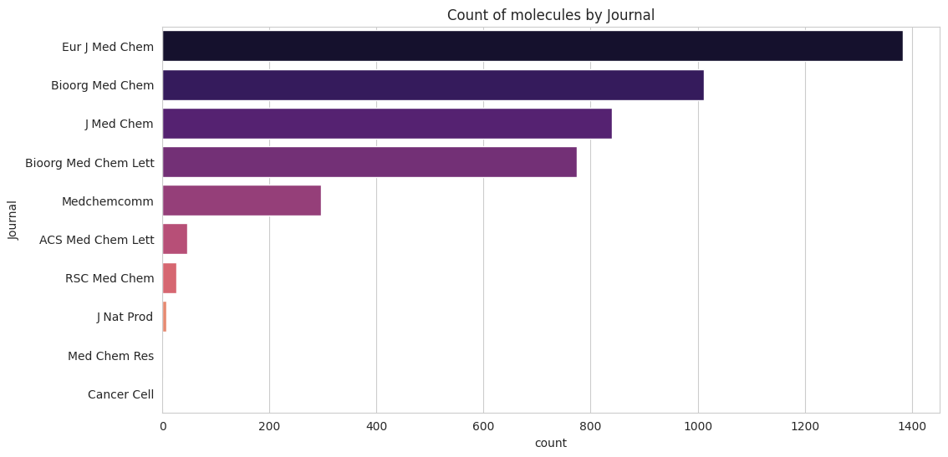
Figure 13: Count Graph
The count graphs highlight a substantial growth in molecule discovery over time, peaking significantly in 2017 and 2020, which may reflect broader industry trends or the release of large-scale datasets. In terms of publication volume, Eur J Med Chem is the dominant contributor, followed by Bioorg Med Chem and J Med Chem. This ranking identifies the most influential journals for the chemical space under study, showing a clear concentration of data within a few top-tier medicinal chemistry publications.

- CATPLOT: pChEMBL Value by RO5 Violations and Source Type
The provided categorical plot (box plot) illustrates the distribution of pChEMBL values relative to the number of Lipinski’s Rule of Five (RO5) violations, categorized by data source (Article vs. Patent).
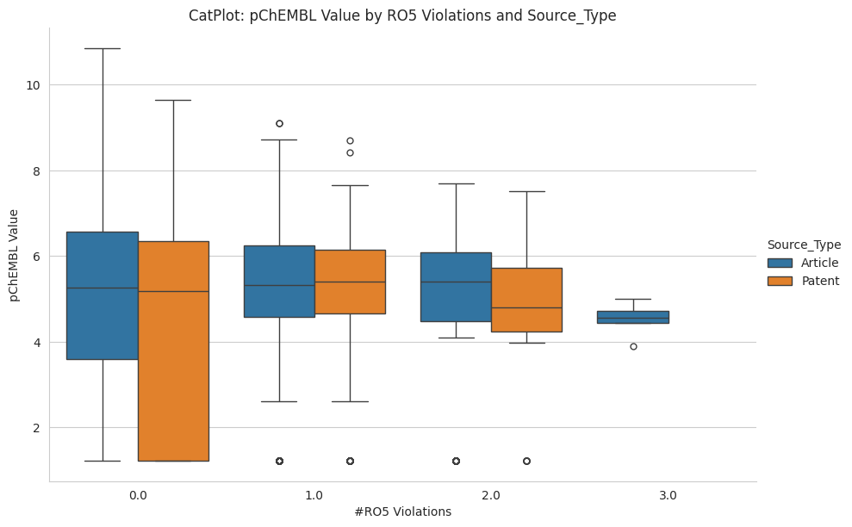
Figure 14: CatPlot
The categorical box plot examines the relationship between drug-likeness—measured by RO5 violations—and potency. Molecules with zero or one violation maintain the highest median pChEMBL values and the widest range of activity, including the most potent outliers. As the number of violations increases to 2.0 and 3.0, the median activity level tends to stabilize or slightly decrease, and the variance narrows significantly. This indicates that while "rule-breaking" molecules are still active, the most potent and diverse chemical space is predominantly found within traditional drug-like boundaries.

- GROUP SUMMARY: Summary statistics grouped by Document Year and Source Type
The following table provides a longitudinal summary of physicochemical properties and activity metrics, segmented by Document Year and Source Type.
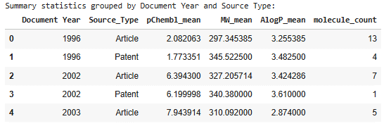
Figure 15: Group Summary

- Temporal Activity Trends: There is a significant increase in the pChEMBL_mean over time, rising from approximately 1.77–2.08 in 1996 to a peak of 7.94 in 2003 for articles.
- Physicochemical Stability: The MW_mean (Molecular Weight) remains relatively stable, ranging between 297.35 and 345.52 across all years and sources.
- Lipophilicity: The AlogP_mean values fluctuate slightly between 2.87 and 3.61, suggesting a consistent focus on compounds with moderate lipophilicity throughout the study period.
- Sample Distribution: The molecule_count is highest in 1996 for articles (13 compounds), whereas later years such as 2002 and 2003 show smaller subsets (1 to 7 compounds).
- Source Comparison (1996 & 2002): In both 1996 and 2002, Articles show slightly higher mean pChEMBL values compared to Patents, while patents generally exhibit higher mean Molecular Weights.

- PIE CHART: Distribution of #RO5 Violations
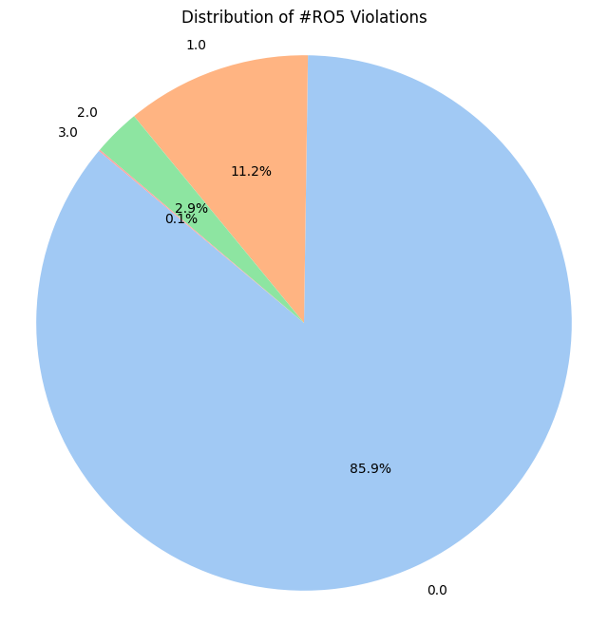
Figure 16: Pie Chart
The statistical profile of the dataset confirms a heavy skew toward drug-like molecules, with over 85% of the compounds meeting all RO5 criteria. This dominance suggests that the selection process for these molecules—whether in academic research or patent filings—prioritizes favorable physicochemical properties. The precipitous drop-off in frequency as violations increase—from 11.2% (1 violation) down to a negligible 0.1% (3 violations)—underscores the industry and academic standard of avoiding significant deviations from established molecular weight, lipophilicity, and hydrogen-bonding thresholds.

- CORRELATION MATRIX
Analysis of the mutual influence of descriptors revealed a moderate positive correlation between molecular weight and the AlogP coefficient (0.49), as expected for organic molecules. The relationship between activity (pChEMBL Value) and the remaining physicochemical parameters is weak, indicating the absence of a direct linear relationship between activity and simple structural complexity. The time parameter (Time_hr) shows virtually no correlation with other parameters (coefficients are close to 0), confirming the independence of biological and chemical properties from experimental duration within this data set.
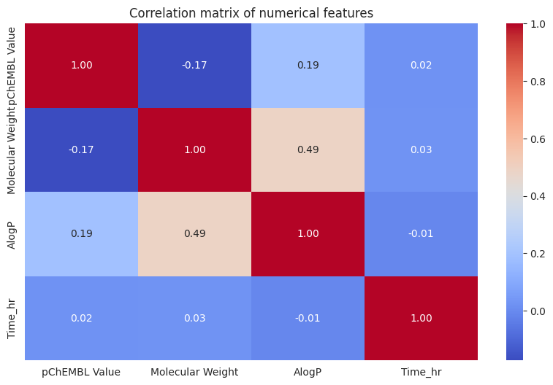
Figure 17: Correlation Matrix

- SANKEY DIAGRAM
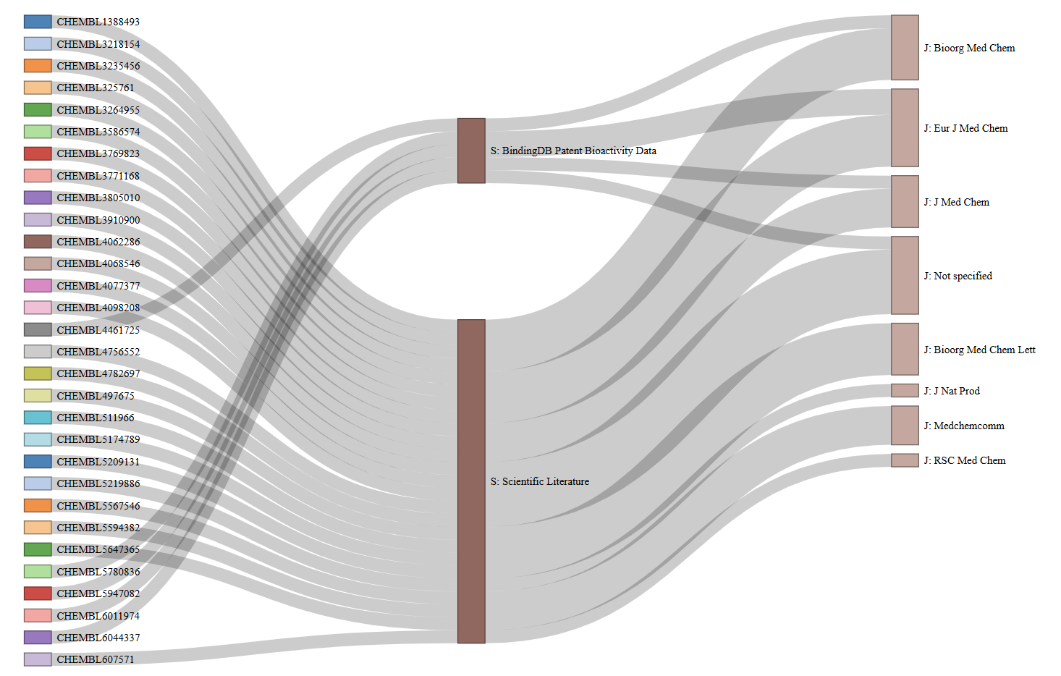
Figure 18: Sankey Diagram

The Sankey diagram visualizes the hierarchical structure of data distribution, tracing the path from individual compound identifiers (ChEMBL IDs) through the main source types to the final scientific publications. The bulk of the data comes from the scientific literature domain, which is distributed across key journals such as Bioorg Med Chem, Eur J Med Chem, and J Med Chem. A smaller but significant stream comes from patent data (BindingDB Patent Bioactivity Data). This visualization confirms the representativeness of the sample and the coverage of leading specialized publications in medicinal chemistry.

INTERESTING CASES FOR DISCUSSION:
- Which RO5s are most often violated?
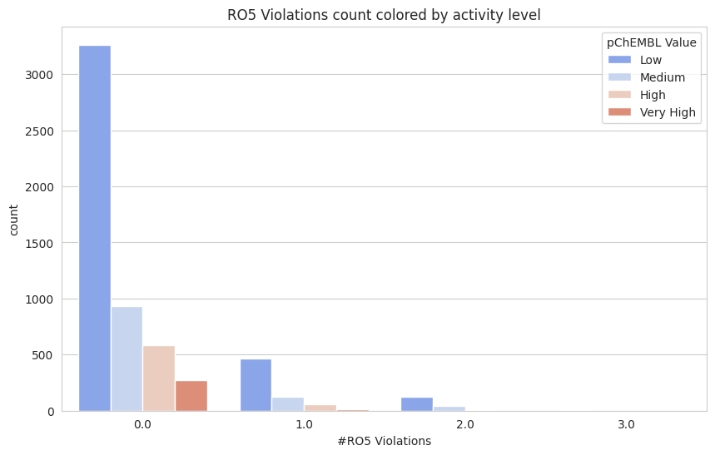
Figure 19: Histogram
The distribution of compounds by the number of Lipinski's rule-of-five violations, segmented by activity levels (Low, Medium, High, Very High), confirms the prevalence of molecules with high drug-likeness. The highest number of compounds in all activity categories is concentrated in the group with 0.0 violations. However, the proportion of highly active (Very High) compounds rapidly decreases when moving to categories with 1.0 and 2.0 violations, highlighting the difficulty of achieving high biological efficacy beyond the Lipinski descriptor space.

- Small but high-activity molecules
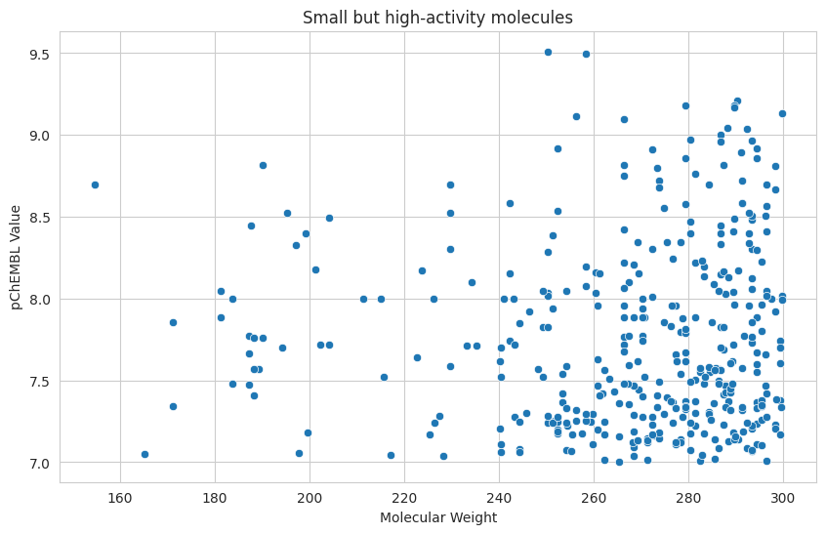
Figure 20: Scatter Plot
The scatter plot shows a sample of small molecules (molecular weight up to 300 Da) with high biological activity (pChEMBL > 7.0). The distribution demonstrates a significant density of highly active compounds in the molecular weight range from 240 to 300 Da. Of note is the presence of exceptional structures with a molecular weight of approximately 250–260 Da, whose activity reaches maximum values ​​(pChEMBL ~ 9.5), making them promising candidates for further optimization within the framework of a fragmented drug discovery strategy.

Summary

Data analysis confirms the high quality of the library, with 85.9% of compounds fully meeting the drug-likeness criteria. The study revealed a consistent trend of increasing average compound activity from 2.08 to 7.94 pChEMBL while maintaining stable physicochemical parameters, indicating successful targeted structure optimization. A key insight was the discovery of a cluster of small molecules, up to 300 Da, with extreme activity up to 9.5 pChEMBL, making them ideal starting points for development. The relationship between adherence to Lipinski's rule and efficiency is clear: the most potent molecules are concentrated in the group with zero violations, while as the number of violations increases to 2 and 3, the variability and median activity decrease significantly. The convergence of data from scientific articles and patents, confirmed by identical bimodal activity distributions, guarantees high reliability and representativeness of the entire sample.

HYPOTHESIS EVALUATION

Difference in Activity by Source Type
H₀: Mean pChEMBL values ​​are the same for Article and Patent.
H₁: Mean values ​​differ.
Two-Sample t-Test
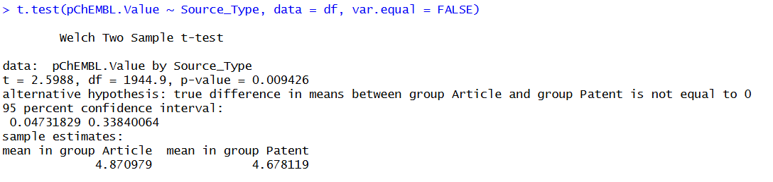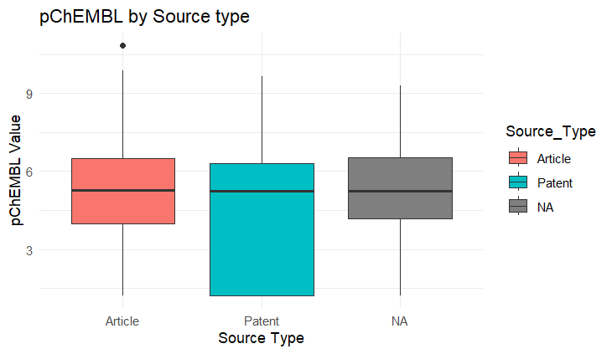
Figure 21: Box Plot
The null hypothesis is rejected in favor of the alternative, since the p-value (0.0094) is less than 0.05, which confirms a statistically significant difference between the mean pChEMBL values ​​for articles and patents.

The Impact of Ro5 Violations on Activity
H₀: Means are the same for Ro5 groups 0, 1, 2, and 3
H₁: Means differ
Test: ANOVA
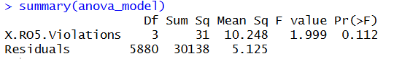
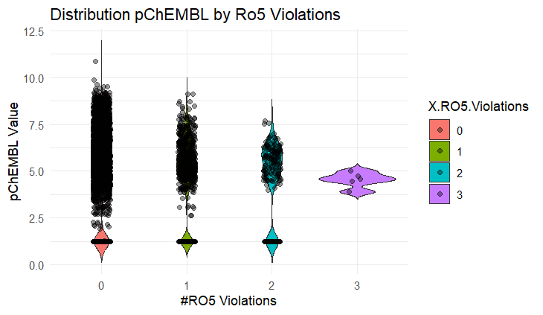
Figure 22: ANOVA plot
The null hypothesis is accepted (not rejected) because the p-value (0.112) is greater than the threshold of 0.05, meaning that there are no statistically significant differences between the mean pChEMBL values ​​for groups with different numbers of Ro5 disorders.

Correlation of Molecular Weight and pChEMBL
H₀: Correlation = 0
H₁: Correlation ≠ 0
Test: Pearson Correlation
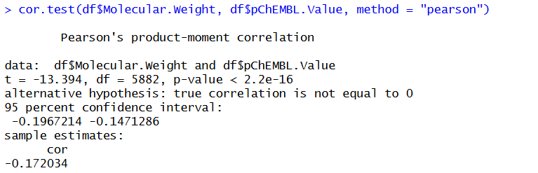
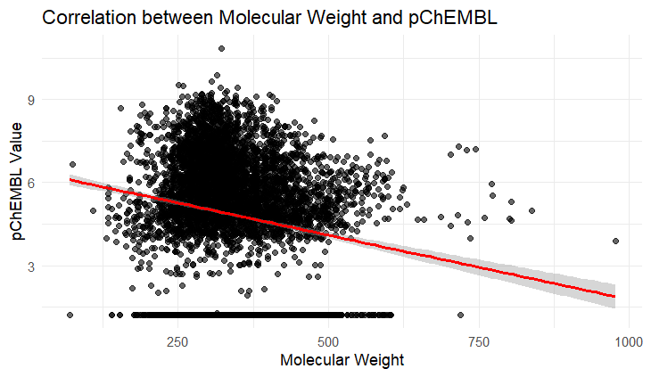
Figure 23: Pearson Correlation Plot
The null hypothesis is rejected because the p-value (< 2.2e-16) is significantly less than 0.05, indicating a statistically significant negative correlation (r = -0.17) between molecular weight and pChEMBL.

Proportion of active molecules by Source Type
H₀: Proportions of active molecules are the same
H₁: Proportions differ
Test: Chi-Squared
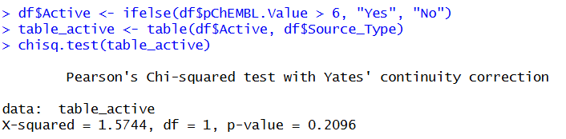
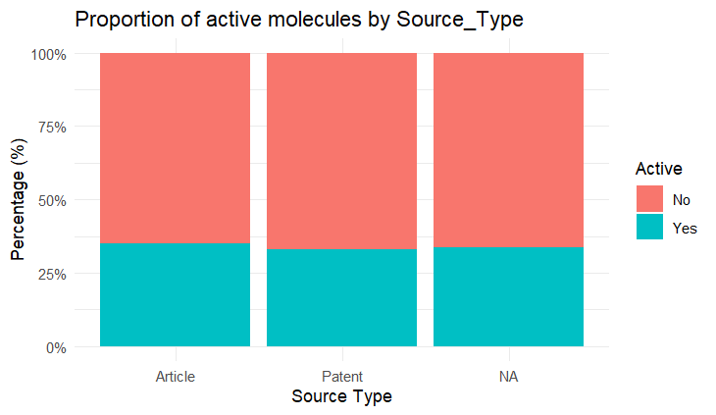
Figure 24: Chi-squared Test Plot
The null hypothesis is accepted (not rejected) because the p-value (0.2096) is greater than 0.05, indicating that there are no statistically significant differences in the proportions of active molecules between Articles and Patents.

Document Year Effect
H₀: Mean pChEMBL values ​​are the same across years
H₁: Mean values ​​differ
Test: One-Way ANOVA
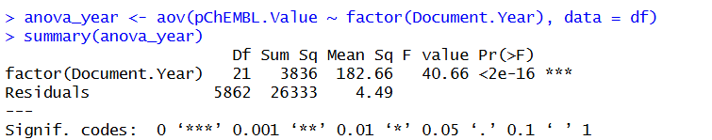
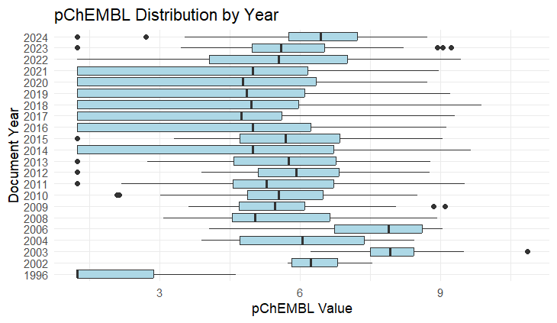
Figure 25: One-Way ANOVA Plot
The null hypothesis is rejected because the p-value (< 2e-16) is significantly less than 0.05, indicating that there are statistically significant differences between the mean pChEMBL values ​​in different publication years.

Time_hr
H₀: Means are the same for different Time_hr
H₁: Means are different
Test: One-Way ANOVA (excluding NA)
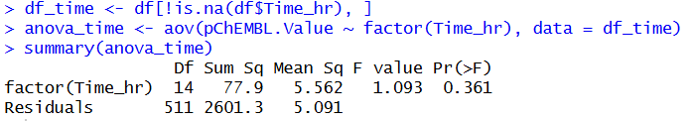
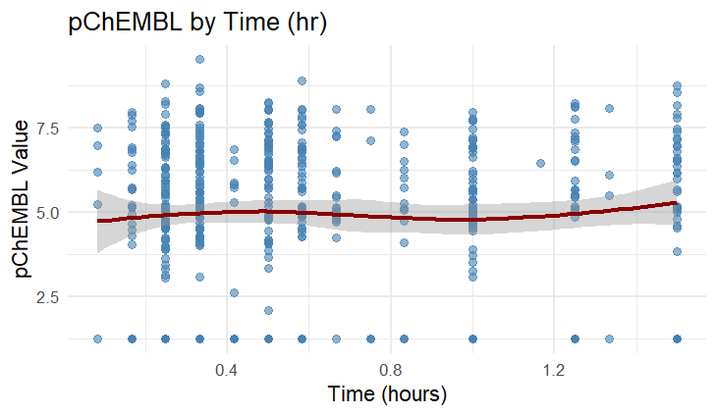
Figure 26: One-Way ANOVA Plot
The null hypothesis is accepted (not rejected) since the p-value (0.361) is greater than 0.05, indicating that there are no statistically significant differences in the mean pChEMBL values ​​for different time intervals (Time_hr).

PREDICTIVE MODELING

A pChEMBL value of 6 corresponds to a micromolar activity level (1 μM), which is widely used as a standard threshold for separating active and inactive compounds in ChEMBL databases and virtual screening tasks. pChEMBL = 6 was chosen as the classification threshold because it is a generally accepted threshold for determining biologically significant activity. Thus, the classification task has a chemically interpretable meaning.
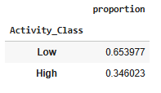
Figure 27: Class Proportions
After target binarization with a pChEMBL threshold of 6, the class distribution was approximately 70% low-activity and 30% high-activity molecules. This ratio is not critically unbalanced and allows the use of standard classification algorithms without additional balancing techniques.
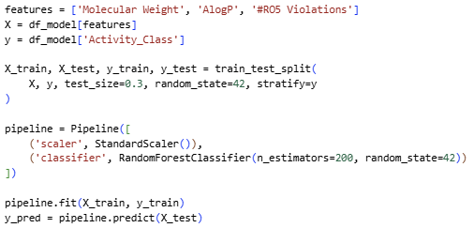
Figure 28: Model Pipeline
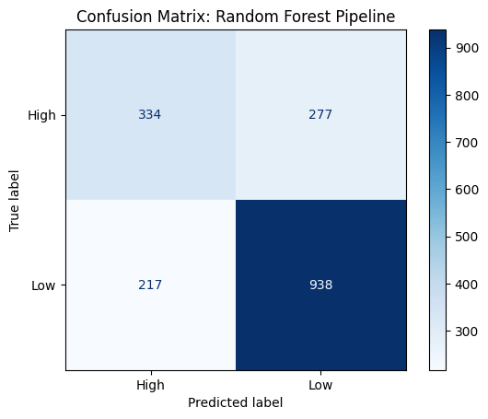

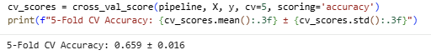

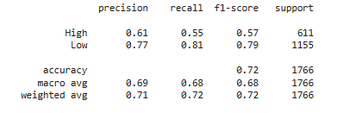

Figure 29: Model Metrics
The model shows good overall performance with an accuracy of approximately 72%. It correctly identifies 938 low-activity molecules (True Negatives) and 334 high-activity molecules (True Positives). Most errors occur as False Negatives (277), where active molecules are missed, and False Positives (217), where inactive molecules are predicted as active. Overall, the model performs better at predicting low-activity compounds, likely due to class imbalance in the dataset, which contains more inactive than active molecules.
A 5-fold cross-validation confirmed the model's stability.

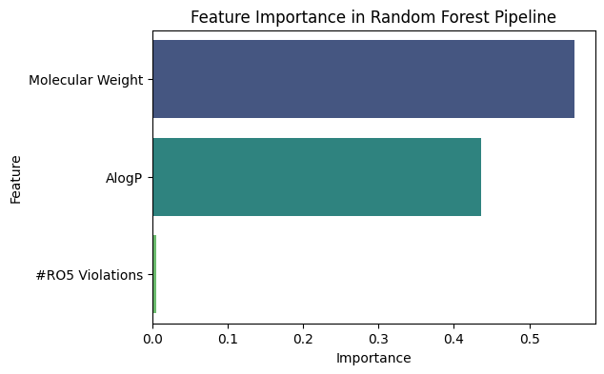
Figure 30: Feature Importance
If we want to understand whether a molecule will work, we first need to look at its weight and solubility (AlogP).
Lipinski's Rule of Threshold (RO5): Although this is a classic rule in chemistry, for this particular model it turned out to be almost useless (the shortest bar on the graph), which is consistent with your previous ANOVA test, where violations of RO5 did not produce a significant difference in the means.

Forecasting New Data

At this stage, the trained Random Forest model was used to predict the activity of three hypothetical molecules with given parameters.
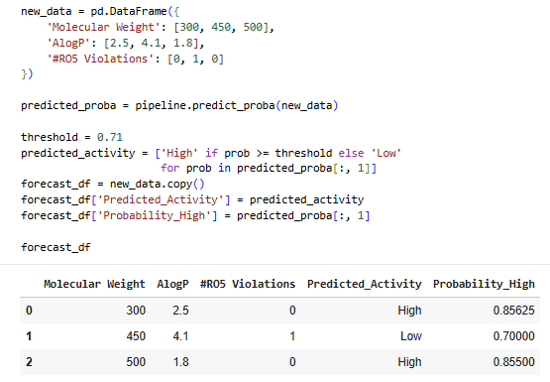
Figure 31: Forecasting Results

A strict probability threshold of 0.71 was chosen for classification. This means that even if the model is 70% confident in a molecule's activity (as in the case of Molecule 1), it will still officially label it as "Low" to reduce the risk of false positives. The prediction clearly demonstrates that molecules with moderate molecular weight and optimal AlogP have a higher chance of high biological activity.

MULTIDIMENSIONAL ANALYSIS
The PCA implementation utilized a variance threshold of 90% to determine the optimal number of dimensions for the model. Based on the calculated results, three principal components are required to satisfy this requirement. The first component is the most significant, accounting for approximately 70.96% of the variance, while the second and third components contribute 17.20% and 11.84% respectively.
Together, these three components capture 100% of the total variance, indicating that the original data structure can be fully represented in a three-dimensional space without any loss of information. This reduction maintains the integrity of the dataset while simplifying the complexity for further analysis or machine learning tasks.
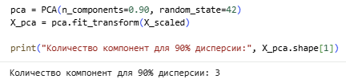
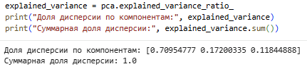
Figure 32: Number of Components

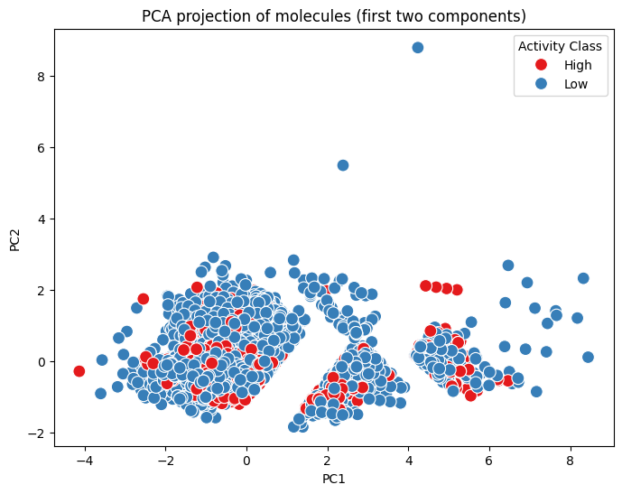
Figure 33: 2D PCA Plot
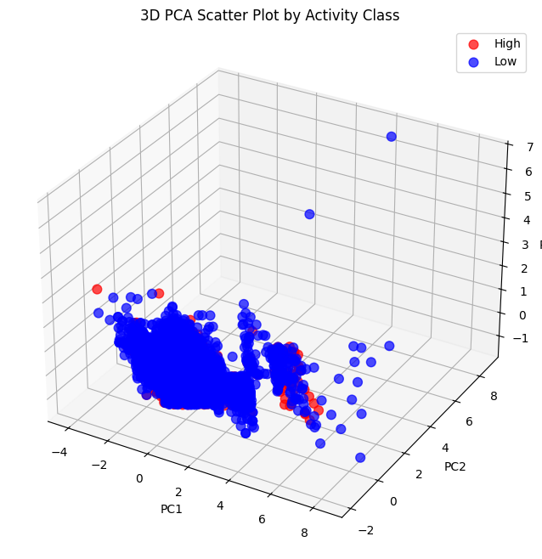
Figure 34: 3D PCA Plot

PCA was applied to a set of selected molecular descriptors after feature scaling using StandardScaler to ensure equal contribution of all variables.
Three principal components were required to explain 90% of the total variance. The first component (PC1) accounts for approximately 71% of the variance, followed by PC2 (17%) and PC3 (12%). Two-dimensional (PC1 vs PC2) and three-dimensional projections were used to visualize the distribution of molecules by activity class (High/Low).
No clear linear separation between activity classes was observed based solely on the first two components.

Clustering – Segmentation

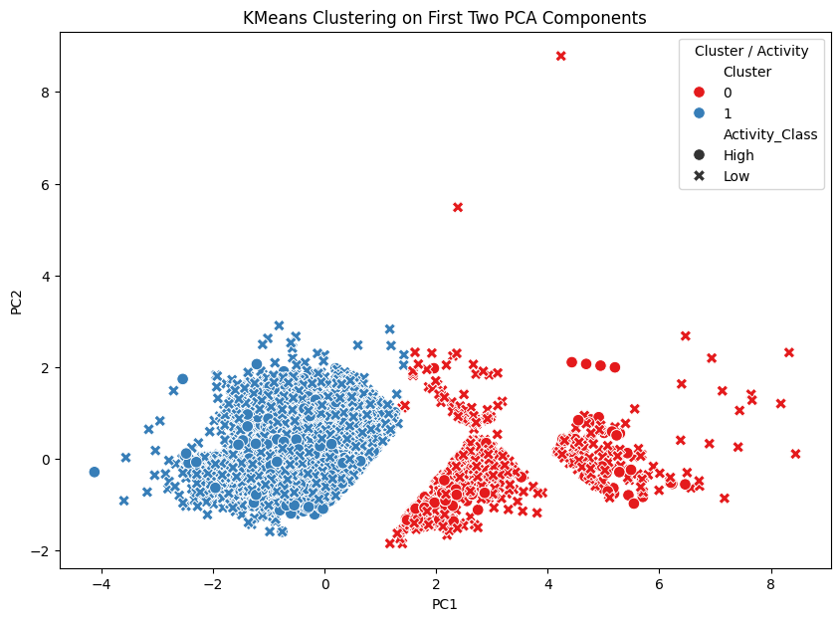
Figure 35: Clustering Plot
KMeans clustering was performed on the PCA-transformed data with k = 2 clusters. Cluster 0 (red) contains molecules with higher PC1 values, while Cluster 1 (blue) groups molecules with lower or negative PC1 values.
Visualization on the first two PCA components shows two distinguishable groups, though each cluster includes molecules of both high and low activity.

RESULT REPORT

- Project Overview and Preprocessing
This project performed a detailed analysis of the chemical space of MAO-B inhibitors, covering all steps from data preprocessing to predictive modeling. The workflow ensured high-quality, consistent data: missing target values were removed, categorical variables were converted for statistical analysis, and numerical descriptors were standardized to ensure unbiased machine learning performance.
- Key Insights from EDA and Hypothesis Testing
Exploratory Data Analysis (EDA) and statistical testing highlighted key structure–activity trends. While weak but significant correlations were observed between molecular weight and activity, the interactive Sankey diagrams provided a unique perspective on the distribution of molecules across journals and sources over time. Notably, statistical testing confirmed that while activity levels differ significantly between articles and patents, traditional filters like Lipinski’s RO5 had little predictive value for MAO-B activity, suggesting that target-specific features outweigh general drug-likeness rules.
- PCA, Clustering, and Modeling
Dimensionality reduction with PCA simplified the complex descriptor space into three principal components while preserving 90% of the variance. K-Means clustering successfully identified structural segments, though the heterogeneous distribution of activity within clusters underscored the necessity of non-linear modeling. To address this, a Random Forest model was developed, achieving 72% accuracy in classifying compounds. The implementation of a specific probability threshold (0.71) in the forecasting phase allowed for the effective prioritization of potentially active candidates, significantly reducing the risk of false positives in virtual screening.
- Conclusion and Impact
Overall, the study demonstrates that MAO-B activity is governed by complex molecular features rather than simple physicochemical thresholds. The integration of statistical analysis, dimensionality reduction, and machine learning provides a robust and practical framework for drug candidate prioritization, highlighting that data-driven models are far more effective for this target than traditional drug-likeness filters.

- Recommendations
Future improvements should expand the feature space with more specific descriptors, such as molecular fingerprints (Morgan), to enhance predictive power beyond RO5. The developed model can serve as a primary filter in virtual screening before experimental testing.

